SING ME TO THE SEA
A hydropool adventure created by Anna Newell (www.annanewell.co.uk)
for children and young people with complex needs
Created in 2018 in partnership with Enable Ireland and St Catherine’s School
funded by Wicklow County Arts Office with design funded by Riverbank Arts Centre, Newbridge
2019 tour funded by Arts Council of Ireland & presented in partnership with the Civic, Tallaght, The Mermaid, Bray, Draiocht Blanchardstown, St Michael’s House, Fingal County Council, St Gabriel’s Centre, Limerick Arts Office, Enable Ireland, Riverbank Arts Centre, Holy Angels Daycare & Carlow Arts Festival

Video promo: https://www.youtube.com/watch?v=mHI6Zq-OJbg&t=16s
Longer video with commentary from our creative consultants: https://www.youtube.com/watch?v=HQZHOpOG3hE&t=9s

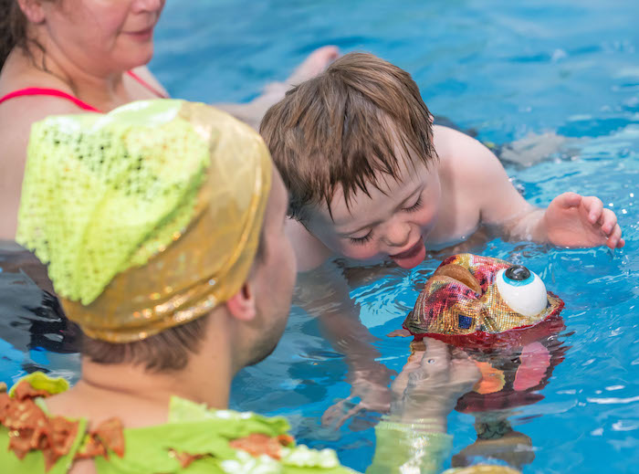

“This show has transformed how we think about using the resource that is our hydropool”
Staff member, Mid Kildare Network Disability Team

“SING ME TO THE SEA is a unique production which engages individuals with even the most profound level of disability in an enriching musical and artistic experience. As a society, we aim to remove barriers to participation; we make art galleries and concert halls physically accessible. However, for so many children, their disabilities go beyond the physical. They may be able to physically access buildings which house the arts, however, the content of these buildings is not often meaningful to them. SING ME TO THE SEA brought an experience of the arts to the children of St Catherine’s. It was beautiful, it was awe inspiring and it was meaningful.”
Physiotherapist, St Catherine’s School, Newcastle, County Wicklow

AUDIENCE FEEDBACK

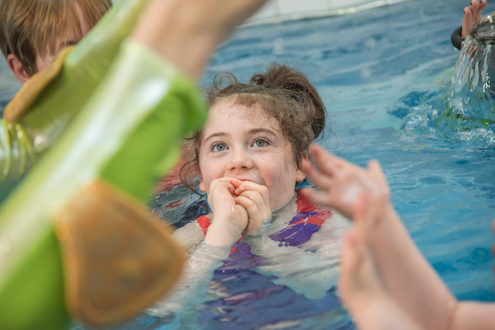

“they were in awe”

“such a special and magical experience”

“what a unique experience the children had. You understand their needs so well”

“what a spectacular experience for our pupils to engage with – they were mesmerised from start to finish”

“just…..WOW”

“amazing”

“A really amazing experience, my son is non- verbal and was imitating Anna’s movements, also mimicking the movements she made with her mouth as she sang. He was very relaxed after the session. Also, upon leaving the pool he said ‘swimming pool’ very clearly. Very proud moment for mommy”

“this was a truly magical experience for our pupils – they were transported to a land of enchanted mermaids and mesmerising rainbow fish; please come back again!”

“breathtaking”

“it was so emotional”

“one of the nicest things I’ve ever done with my daughter”

“my child was incredibly relaxed, content and engaged”

“an amazing, magical, sensory drama”

“it was almost hypnotic, it was so relaxing”

“our pupils, parents & staff have so enjoyed the show…..we have learned so much too”

“a memory never to be forgotten”

“the most magical morning”

“the children adored every second”

“absolutely magical and so appropriate for our wonderful children”

“I’m sure you all noticed how much my daughter engaged with it! She was enthralled by you all. She loves music and water – so it was perfect for her to really relax and let go. I was very moved to be part of something so perfectly tailored to the needs of my little girl. This doesn’t happen very often. T has a very significant visual impairment and is registered as legally blind. She also has cerebral palsy, sensory issues and epilepsy. However, in that pool with your team – she was absolutely herself and free.”

“my son really took to it, he loved the strainer and watching himself in the mirror ball, he also began to imitate the performers’ actions, which is a new thing for him”

“Jules was loving it, he was smiling a lot and his mother felt like he engaged with her throughout the session and felt a bond with him”

“It was magical. The singing was beautiful, perfect harmonies. M responded so nicely and calmly. Just a wonderful experience enjoyed by mother and child”

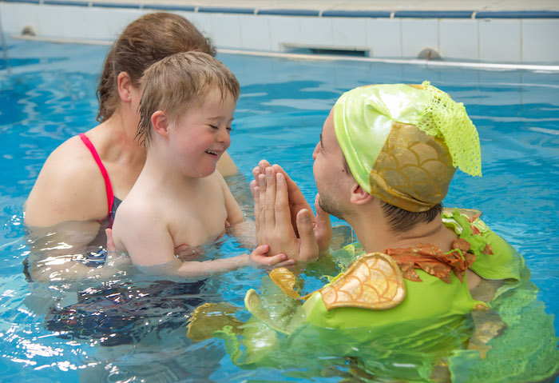

“She was fully relaxed, her eye contact was brilliant and she was comfortable being tactile with people. If she could speak she would tell us she really enjoyed the experience”

“very serene and relaxing”

“The singing was just beautiful and the whole show was perfectly pitched for its target audience”

“What an incredible experience! From the beautiful costumes to the out-of-this-world singing and all the props, S had the time of her life and was so excited by the ‘rain maker’ and seeing herself in the ball. We felt privileged to be part of it, what an experience! It’s simply perfect!”

“fantastic production…..beautiful, calming and amazing attention to the children”

“My son had so much fun at Sing Me To The Sea today. It was the perfect sensory experience for him, and he loved every single minute of it. I've never seen him enjoy anything so much.”

“I’ve never seen anything like it ever. Truly magical”

“what an amazing experience. The quality of presence and interaction was just wonderful”

“my child was so calm and relaxed”

“wonderful experience – a delight for the senses”

“my daughter was totally engaged – truly fantastic”

“this is our second time – we came last week and our son hasn’t talked about anything else since!”

“my son never stays in the water this long!!”

“It was an incredibly spiritual and emotional experience for both the kids and the adults”

“I’ve never seen my boys focus for such an extended period of time ever”

“so beautiful, mesmerising and gentle”

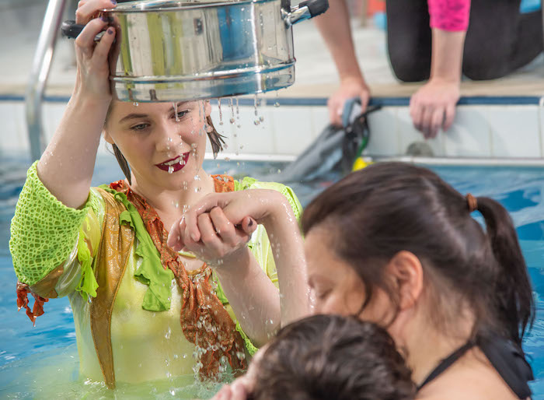

“my daughter loved her session in the pool today. Thank you so much – it was such a magical, beautiful, calming and emotional experience. Something we will never forget”

“Fantastic, he loved it. It was also his first time in the swimming pool”

“Amazing experience, he has been feeling agitated recently and mom was amazed at how calm he became, an emotional experience for mom”

“She loved it, especially the strainers, this was great as she does not enjoy the shower at home. She really enjoyed the sensation of it on her toes”

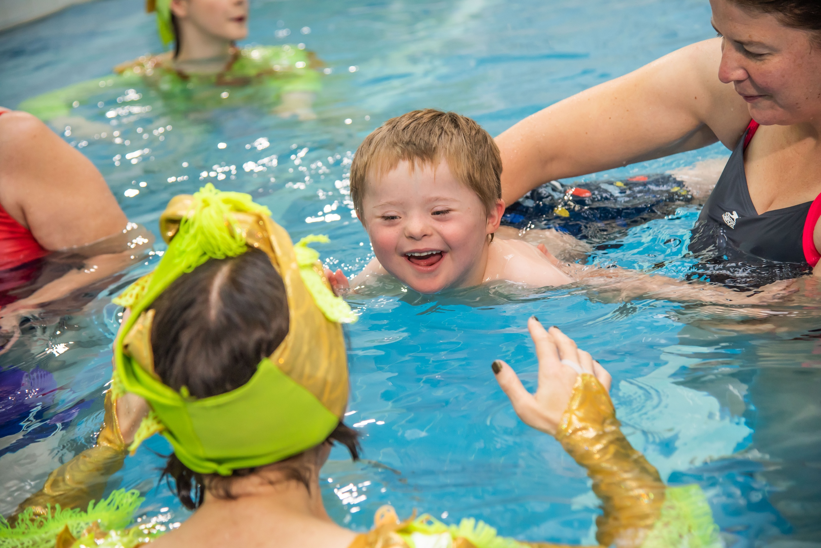

All photos by Neil Harrison. Further info about this work at www.annanewell.co.uk

