CV: ANNA NEWELL
www.annanewell.co.uk
contact@annanewell.co.uk : +44 7949 287405

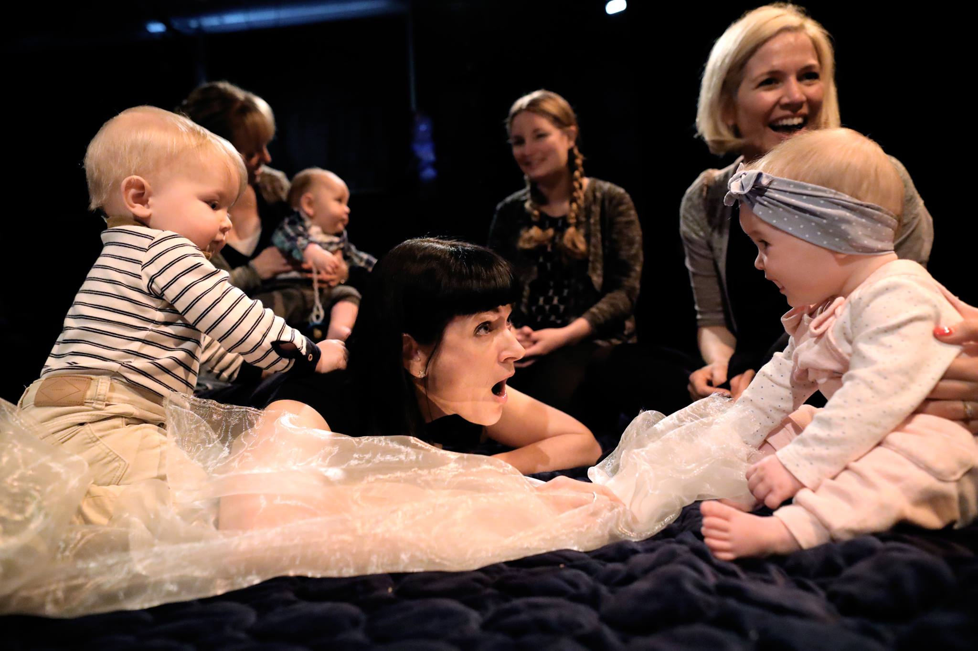
Anna in creative consultation with her audience

Anna Newell has been making theatre adventures for people of all ages to watch and to take part in since 1989 - in theatres of all sizes, in a disused police station, in a shopping centre, on a barge, in a sonic lab, in a hydropool and in a secret apartment - in various cities in the UK and Ireland and also in the US, South Africa and Bosnia. Her work for Early Years has been seen on 6 continents and in every single Sure Start in Belfast.

She created the world’s first BabyDay, introduced home-grown theatre for children and young people with PMLD (Profound and Multiple Learning Difficulties) into Ireland and helped start babytheatre in South Africa. She was one of just 11 finalists globally for the international Ellen Stewart Award 2016 for theatremakers whose practice has a strong social impact with a focus on young people. www.ellenstewart.net . In 2017, she was a recipient of one of the inaugural Tonic Theatre Awards for ‘game-changing women who are re-defining theatre and the performing arts’. She is based in Bray, Ireland.

“a hero of children’s theatre”
The Guardian

“Early Years theatre pioneer”
The Irish Times

Major Arts Council of Ireland Arts Grant Funding for 2021 will see Anna creating The Network For Extraordinary Audiences – a national 7-venue network programming and advocating for audiences of babies, early years and children/young people with complex needs. For the 2021 programme Anna will create GROOVE (a 70’s inspired ‘happening’ full of harmony singing and immersive video for children with complex needs), I LIKE TO MOVE IT MOVE IT (Ireland’s first dance show for babies and MY SMILE HAS FALLEN DOWN (a show for ages 4-6 years old about sadnesss). In addition, she will lead a strategic artist development programme in collaboration with this national network of venues.

Funding from Wicklow Arts Office will enable her to create SWEET DREAMS ARE MADE OF THIS – an intimate flexible adventure for children with complex needs inspired by the at-home touring of SING ME TO THE SEA that she pioneered through the lockdown of spring/summer 2020 - https://www.rte.ie/news/2020/0819/1160124-theatre-children-special-needs/

For information about Anna’s work #keepingitlive during Covid-19 – www.annanewell.co.uk/keepingitlive

2020/1 sees Anna take her babyshow I AM BABA (International Early Childhood Arts Commission 2017) on a further 10-week tour right across Ireland with substantial collaboration with the National Childhood Network and the Children and Young People’s Services Committee under the auspices of TUSLA.

As one of Ireland’s leading Early Years theatremakers, Anna has been invited to mentor an increasing number of emerging artists in the field including Sam Porciello, Monica Munoz, Eamon Sweeney and Muireann D’Arcy.

Arts Council of Ireland Arts Grant Funding enabled a 2018/19 programme of work for early years/children with complex needs in partnership with the Civic, the Mermaid and Draiocht. This comprises BigKidLittleKid (a new physical theatre show for audiences aged 3-6 years) which was also selected for Dublin Theatre Festival 2019, BABY’S FIRST XMAS – an Xmas show especially for babies aged 0-12 months (with a distinct version, LITTLE TINY XMAS, for children under 5 with complex needs) and a 100-show national tour of SING ME TO THE SEA, including at Carlow Arts Festival.

“SING ME TO THE SEA is a unique production which engages individuals with even the most profound level of disability in an enriching musical and artistic experience. As a society, we aim to remove barriers to participation; we make art galleries and concert halls physically accessible. However, for so many children, their disabilities go beyond the physical. They may be able to physically access buildings which house the arts, however, the content of these buildings is not often meaningful to them. SING ME TO THE SEA brought an experience of the arts to the children of St Catherine’s. It was beautiful, it was awe inspiring and it was meaningful.”
Physiotherapist, St Catherine’s School, Newcastle, County Wicklow

Anna was selected as one of the first Polka Lab Artists for a project creating a show for babies with teenage performers to explore the empathetic impact of this experience for the performers with a further development of this project funded by Wicklow Arts Office in collaboration with ImmaLab, Trinity College Dublin. She was granted funding by Dún Laoghaire Rathdown to create BLUE! – an interactive adventure working with the blue block Imagination Playground developed in creative consultation with the Peter McVerry Homeless Hub, which toured Dublin libraries in 2020. Working with Brighton-based puppet theatre, she also created a new show LITTLE MONSTER for audiences aged 3-5 years.

2018/19 projects also included LULLABUB – a show for babies/toddlers (one version for 0-12 months, another for 13-30 months) with Hullabaloo Theatre, Darlington, SING ME TO THE SEA - a new show for children with complex needs that takes place in hydropools (strategic project for Wicklow County Arts Office in collaboration with the Riverbank Arts Centre and Enable Ireland), a pilot Early Years performer training project based at the Civic, Tallaght; and GROW – a new Early Years dance theatre piece for Indy4, the professional wing of Glasgow's Indepen-Dance (Scotland’s inclusive dance company).

In 2017, she directed HUSH-A-BYE, a new Early Years show with the world reknowned Oily Cart, London, TWINKLE TWINKLE, a new show for 18 months to 3 years for Touched Theatre and MESS - a brand new classroom adventure for children with PMLD working with Clown Doctors in Scotland. In 2017, she was awarded the International Early Childhood Arts Commission offered by the four Dublin Local Authorities through Arts Council Ireland’s Invitation to Collaboration Fund to create I AM BABA, a brand new show for babies aged 0-12 months which toured to venues and health settings in Ireland for 6 weeks in autumn 2018.

“This was honestly one of the most amazing experiences. I was nearly in tears; it was magic – you could hear a pin drop. I have never seen the likes of it before.”
Audience feedback, I AM BABA

“[Anna] is an exceptional artist, very skilled at working with families and communities who are not used to going to formal theatre spaces. She has been connecting with local families in a different way in each area and neighbourhood.”
Liz Coman, Dublin City Council, funder for I AM BABA quoted in the Irish Times

In early 2016, Anna relocated to Bray and in 2016/17 created a freelance portfolio of projects including FOUR GO WILD IN WELLIES - a new inclusive dance show for audiences aged 3-5 with Indy4, (presented at the Bangkok International Children’s Festival, Australia’s Awesome Arts Festival, TYA Inclusive Festival, Tokyo and heading off-Broadway in 2020. Selected for Made In Scotland Showcase, 2018 Edinburgh Festival Fringe, winner of one of the Edinburgh Three Weeks’ Editors’ Awards).

“Thirty minutes of sheer delight”
Arts:Blog, FOUR GO WILD IN WELLIES

Between 2011 and March 2016, Anna was Artistic Director at Northern Ireland’s longest running children’s theatre company, Replay Theatre Company (www.replaytheatreco.org). Under her artistic leadership and with the support of Tim Webb, the company became the first company on the island of Ireland (and one of just a few globally) to create work for audiences of children and young people with PMLD and her first show for this audience – BLISS – was selected as one of only 10 shows from the UK/Ireland to be presented at Assitej (the World Congress of Theatre for Children and Young People) in Birmingham 2016. Replay’s programme of work for this audience received funding from BBC Children in Need and was the only NI project to be featured on the BBC Children in Need National Appeal Programme in 2015.

“In all my 21 years of teaching, I have never seen such high-quality work for this audience as that which Replay produces”
Principal, Parkview Special School on INTO THE BLUE (PMLD poolshow)

Under her artistic leadership, the company also began to make work for the very young with their youngest audience member being only 4 days old. Having rarely toured outside NI prior to Anna taking up post, Replay now regularly tours to venues and festivals in the UK and the Republic of Ireland and in 2015, the company toured off-Broadway.

It was, perhaps, the most immersive theater experience I’ve had since I saw an adaptation of Faulkner’s As I Lay Dying staged inside a 15×15 foot crate. (And, yes I’ve seen Sleep No More)
Blog review of BABBLE off-Broadway http://ninamansfield.com/blog1/2015/04/01/babble-leads-to-babbling/

Anna’s babyshow TiNY for Replay was the first ever babytheatre in South Africa, where she also led intensive workshops with Cape Town’s Magnet Theatre Company to catalyse a homegrown babytheatre movement. This was as a result of a SA-UK Seasons Fund grant (British Council in SA and the National Arts Council of South Africa) which she secured for the company in collaboration with Magnet.

“this has been the most paradigm-shifting experience for us”
Jennie Reznek, Magnet Theatre, Cape Town

For Replay, Anna conceived, was part of the team that won funding for and led the team that delivered, the world’s first BabyDay – www.annanewell.co.uk/babyday and
https://vimeo.com/152850215 . On 27 September 2015, in excess of 15,000 people came to over 80 events in more than 20 venues across the city and the year-long engagement programme with every single Sure Start in Belfast leading up to BabyDay meant that the project had a genuinely broad and diverse demographic and engaged families and communities considered traditionally harder to reach. Anna was invited to sit on the Belfast Infant Mental Health & Wellbeing Working Group and leading Early Years guru, Dr Suzanne Zeedyk is now an informal mentor and major advocate for Anna’s work.

Anna was invited to work as International Artist in Residence with Polyglot Theatre, Melbourne in 2013.

In late 2015, Anna was invited to put together a NI event as part of the Battersea Arts Centre/The Guardian’s A Nation’s Theatre project and was also invited to write post-event editorial for The Guardian, in addition to a previous blog - http://www.theguardian.com/stage/theatreblog/2015/sep/22/theatre-babies-arts-babyday-belfast

She directed REVENGE and BRUISED for Tinderbox Theatre Company, BE MY BABY for the Lyric Theatre, co-directed TR>UBLE for TheatreofplucK (4-star review in the Irish Times) and directed REASSEMBLED, SLIGHTLY ASKEW, a unique sonic installation piece by Shannon Yee inspired by Shannon’s acquired brain injury. The show received a 5-star review in The Stage and 4 stars in the Guardian and Time Out London. It was in residence in Battersea Arts Centre in 2016 as the only NI production in their A Nation’s Theatre season and played two weeks at the Dublin Tiger Festival Fringe where it was nominated for 3 awards. It continues to tour internationally, most recently to Canada.

“A real-life ordeal, captured by a daring, disorientating artistic collaboration, which works brilliantly on so many levels *****”
The Stage on REASSEMBLED, SLIGHTLY ASKEW

Anna was the Artistic Director of the Centre for Excellence for the Creative and Performing Arts at Queen’s University from 2005-2010 (www.qub.ac.uk/cecpa ), devising and delivering a pilot performer training programme and other innovative interdisciplinary practical arts programmes including devised dance theatre created with medical students – for which they got the same credit as their peers doing clinical electives. Also during this time, she created an interdisciplinary MA which involved collaboration with a range of external artists including Talking Birds, Pat Murphy, the Sonic Arts Research Centre and Forced Entertainment.

She also created two pieces of work with students from the Sarajevo Academy of Performing Arts, one for Bosnia’s International MESS Festival.

“an adventure beyond theatre”
official MES Festival reviewer on NIJE NAS STRAH, MESS FESTIVAL, Sarajevo

She ran the Lyric Theatre Belfast’s actor training programme for two years, during which time they produced the Presnyakov Brothers’ TERRORISM, Moira Buffini’s A VAMPIRE STORY and two performance installations.

Prior to moving to Belfast, she was Associate Director at Dundee Rep where she directed a number of large-scale pieces including Liz Lochhead’s DRACULA, Enda Walsh’s DISCO PIGS, Neil Duffield’s JUNGLE BOOK, Jim Cartwright’s RISE AND FALL OF LITTLE VOICE and Charlotte Keatley’s MY MOTHER SAID I NEVER SHOULD. She directed large-scale community projects including Ariel Dorfmann’s WIDOWS and an original operetta by Michael Marra. She also co-directed community co-productions between Dundee Rep and the Playhouse on the Square, Memphis and the Royal Court and was a key player in the setting up of the Dundee Women’s Performing Arts Network.

“Extremely haunting and emotional…The finale is especially notable for its immense power: vocally, visually and emotionally”
The Edinburgh Guide - Theatre Review on WIDOWS

Anna has directed for various companies in Scotland and England including Borderline Theatre Company, Pilot Theatre Company and Birds of Paradise as well as teaching at Queen Margaret University and undertaking tens of community projects diverse in scale and nature.

She has been running large-scale community acapella harmony women’s singing groups for nearly 20 years and these groups have supported, amongst others, Eddi Reader, Mary Black and Brian Kennedy.

She has also created a whole range of bespoke training projects from single day CPD experiences to an 11-week ensemble training performer training programme at QUB; from weekend workshops with Sure Start staff to the intensive week catalyzing the creating of the first ever homegrown babytheatre in South Africa to an intensive two-week Early Year training course for music educators in Music Generation Carlow.

“What an incredible two weeks of music, laughter, learning, creativity and joy….this has been the best learning experience I have ever undertaken……thank you for the shift in perspective…….the most beautiful, creative process I have ever experienced…”

music educators feedback from two-week intensive training (Music Generation Carlow)
​
​

REFEREES:
Suzanne Zeedyk, Early Years Research Psychologist
(www.suzannezeedyk.com) - Suzanne@suzannezeedyk.com

Sue Giles, International Theatremaker and the Australian Council Member for ASSITEJ, the World Congress of Theatre for Children and Young People
(www.polyglot.org.au) - sue@polyglot.org.au

